

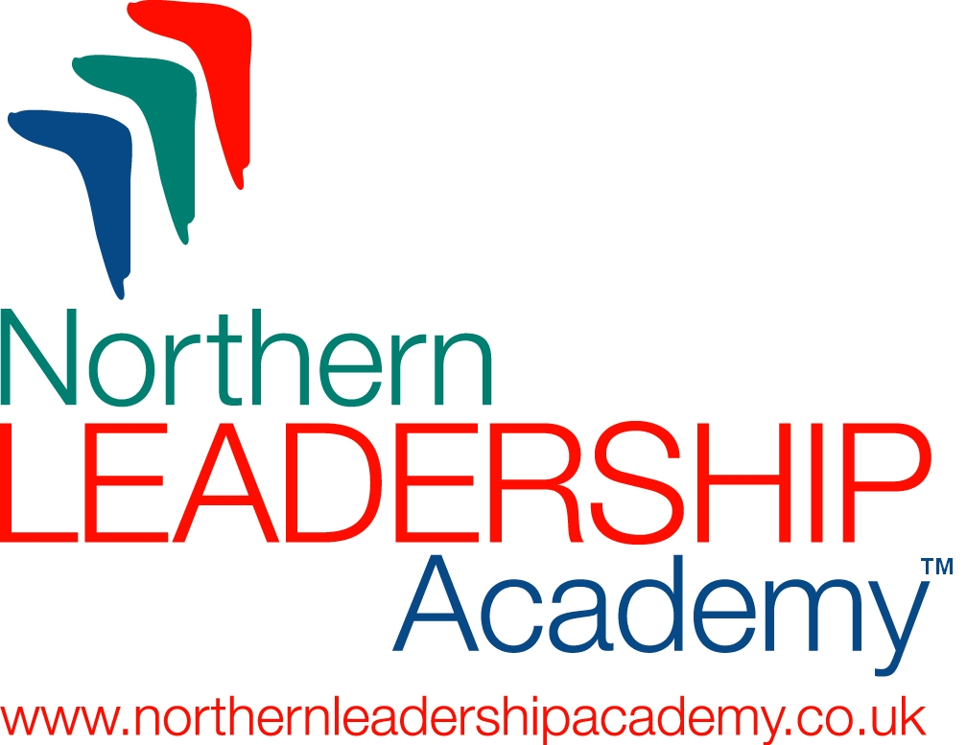

Barnsley Open Space

Thursday 21st May 2009, 9.30 – 16.00
University Campus Barnsley

Come and join managers and leaders from industry and the public sector to one of the key Leadership Development events in Barnsley and district this year.

This is an unrivalled opportunity to share your thoughts about the future of management and leadership, to voice your issues and concerns, to test out your ideas, and initiate action with your fellow industry and public sector colleagues.

Jeff Gold of the Northern Leadership Academy will lead and open the floor to all delegates. You will set the agenda and the ‘law of two feet’ will determine whose ideas are addressed and actioned.

Open Space has been described as ‘passion bounded by responsibility’; ‘a simple and powerful way to get people and organisations moving’ and it’s huge fun!

Many who experience Open Space bring it into their organisations to replace the ‘meetings culture’!
You are invited free, courtesy of West Yorkshire Lifelong Learning Network in partnership with the University Campus Barnsley and the Northern Leadership Academy and other partners. Normally this event would cost £200 per delegate.

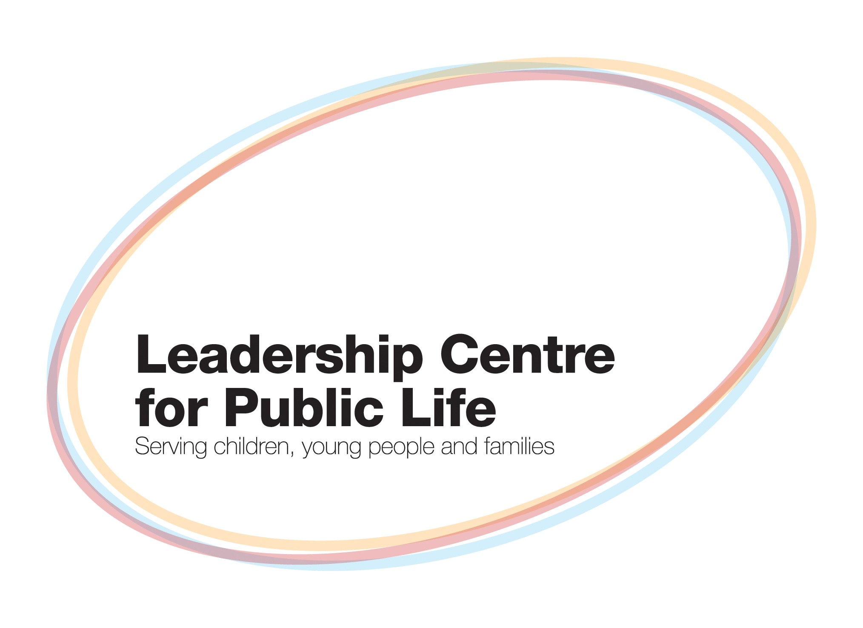



Please return your completed form to wylln@hud.ac.uk or by post to Rachael Brough, Communications & Marketing Manager, WYLLN, University of Huddersfield, Queensgate, Huddersfield HD1 3DH

Booking form Barnsley Open Space

Title: Prof/Dr/Mr/Mrs/Ms/Miss (other)…………………… First Name:…………………………………………

Surname:…………………………………… Job Title: …………………………………………………………………

Institution/Organisation:………………………………………………………………………………………………….

Address:……………………………………………………………………………………………………………………

………………………………………………………………. Post Code: ……………………………………………….

Telephone:…………………………………………Email: ………………………………………………………………

Special Dietary Requirements: ……………………Special Access Requirements: ………………….................

