PROGRAMME SPECIFICATION  Please view the disclaimer. | 

AWARD and COURSE TITLE | BSc (Hons) Psychology and Sociology
INTERMEDIATE AWARDS | Ordinary Degree in Psychology and Sociology  Diploma of Higher Education in Psychology and Sociology  Certificate of Higher Education in Psychology and Sociology
Name of the Teaching Institution | Sheffield Hallam University
Faculty and Department | Faculty of Development and Society  Department of Psychology, Sociology and Politics
Mode(s) of Attendance  (eg. FT/PT/SW/DL) | FT/PT
UCAS CODE | CL83
Professional/Statutory/Regulatory Body Recognising this Programme | British Psychological Society
QAA Subject Benchmark Statement or other relevant external reference point | QAA (2007) Psychology Benchmark Statements  QAA (2007) Sociology Benchmark Statements
Date of Validation | April 2011

1 PROGRAMME AIMS

The BSc Psychology and Sociology programme aims to:

Provide a comprehensive and thorough knowledge and understanding of the core areas of psychology and sociology, underpinned by a firm methodological and theoretical base which meets the QAA Subject Benchmarks for both disciplines.
Enable students to develop the key personal and transferable skills for enhancing employability and graduate skills, through embedded academic and professional development, work-related learning and opportunities for international mobility.
Provide a learning environment which supports the academic and professional development of students as reflective and reflexive practitioners.
Provide learning opportunities which are creative and innovative and which introduce students to a range of new developments in the disciplines.
Enable students to develop an understanding of the real life applications of sociological and psychological theory to the social world.

2 PROGRAMME LEARNING OUTCOMES

2.1 Knowledge and understanding covered within the Programme. By the end of the programme you will be able to

- Understand the scientific underpinnings of psychology as a discipline, its historical origins, development and limitations (Psychology QAA Benchmark Statement 7.4.1);
- Describe, explain and apply key concepts and theoretical approaches within sociology (Sociology QAA Benchmark Statement 6.5.1);
- Describe and analyse the nature of social diversity and inequality and their effects (Sociology QAA Benchmark Statement 6.5.2);
- Recognise the inherent variability and diversity of psychological functioning and its significance (Psychology QAA Benchmark Statement 7.4.2);
- Identify meaningful patterns in behaviour and experience and evaluate their significance (Psychology QAA Benchmark Statement 7.6.3);
- Demonstrate systematic knowledge and critical understanding of a range of influences on psychological functioning and how they are conceptualised across the core areas of psychology – Research Methods (Quantitative and Qualitative), Biological Psychology, Cognitive Psychology, Individual Differences, Developmental Psychology and Social Psychology (Psychology QAA Benchmark Statements 7.4.3, 4.6, 4.7, 4.8 & 4.9);
- Describe and analyse the nature of relationships between individuals, groups and social institutions and the processes which underpin social change and social stability (Sociology QAA Benchmark Statements 6.5.4 & 6.5.5)
- Demonstrate detailed knowledge of specialised areas and/or applications in psychology and sociology, some of which are at the cutting edge of research (Psychology QAA Benchmark Statement 7.4.4; Sociology QAA Benchmark Statement 6.9.5);
- Demonstrate knowledge and competence of a range of research paradigms, research methods and measurement techniques, including statistical analysis, through taking part in practical activities, and be aware of their limitations (Psychology QAA Benchmark Statement 7.4.5, 7.6.5 & 7.6.6; Sociology QAA Benchmark Statement 6.5.6).

2.2 Intellectual/Subject/Professional/Key skills covered within the Programme: by the end of the programme you will be able to

- Be computer and information literate in locating, retrieving and synthesising information and confident in using word processing, database and statistical software in order to communicate ideas and research findings, both effectively and fluently, by written, oral and visual means (Psychology QAA Benchmark Statement 7.8.1 & 7.8.3; Sociology QAA Benchmark Statements 4.2, 6.7.2, 6.7.3 & 6.7.4);
- Adopt multiple perspectives and draw on evidence to assess the relative merits of competing explanations of human behaviour, social situations and events in order to understand the role of evidence, make critical judgements about arguments in psychology and sociology and draw reasoned conclusions (Psychology QAA Benchmark Statement 7.6.1 & 7.6.2; Sociology QAA Benchmark Statements 6.5.7, 6.7.1-6.7.4);
- Comprehend and use with confidence numerical, statistical and other forms of data, particularly in the context of presenting and analysing complex data sets (Psychology QAA Benchmark Statements 7.6.6 & 7.8.2; Sociology QAA Benchmark Statement 6.9.3);
- Solve problems by clarifying questions, considering alternative solutions and evaluating outcomes (Psychology QAA Benchmark Statement 7.8.4; Sociology QAA Benchmark Statement 6.9.4);
- Be sensitive to, and react appropriately to, contextual and interpersonal factors in groups and teams (Psychology QAA Benchmark Statement 7.8.5);
- Undertake self-directed study and project management, in order to meet desired objectives (Psychology QAA Benchmark Statement 7.8.6);
- Take charge of own learning, and reflect on progress by evaluating personal strengths and weaknesses, in order to develop the skills and knowledge necessary for future study and employability by the application of psychology and sociology to the workplace (Psychology QAA Benchmark Statements 7.8.7 & 5.5.10; Sociology QAA Benchmark Statements 4.2.7; 4.4.1; 4.4.6 & 4.4.7);
- Competently initiate, design, conduct and report an empirically-based research project under appropriate supervision, and recognise its theoretical, practical and methodological implications and limitations (Psychology QAA Benchmark Statement 7.6.7);
- Be aware of ethical principles and approval procedures and demonstrate these in relation to own study, and be aware of the ethical context of social research (Psychology QAA Benchmark Statement 7.6.8; Sociology QAA Benchmark Statement 6.9.5).

3 LEARNING, TEACHING AND ASSESSMENT

3.1 The approach to Learning and Teaching within the Programme

Our approach to teaching and learning is founded on the existence of highly motivated, enthusiastic and knowledgeable staff groups in Psychology and Sociology. Collectively, we are a relatively large subject group, so we are able to offer high quality provision of core psychology and sociology teaching, whilst at the same time offer a wide range of expertise in more specialist areas.

The approach to learning, teaching and assessment (LTA) within the BSc Psychology & Sociology course is guided by the four key LTA enhancement themes identified within the Faculty Learning, Teaching and Assessment Strategy:

Effective and efficient assessment and feedback practice;
Ensuring that students are well equipped for the world of work;
Supporting student transition, progression and achievement;
Preparing students for a global world.

Effective and Efficient Assessment and Feedback Practice
In seeking to improve students’ experience of learning in HE, the first LTA enhancement theme focuses on assessment and feedback practice. The structure of the modules on the BSc Psychology & Sociology course have been developed collectively within the departmental staff groups, to ensure that there is close integration between the modules and a sense of a progression through the degree, in terms of the accumulation of knowledge and skills development. In this way, the staff groups have an appreciation of where each module fits within, and contributes towards, the course as a whole. The course provides an effective assessment practice by promoting incremental, cumulative learning which builds year on year, culminating in modules which require greater specialisation and assessments which require a critical stance in the final year of study.

There is efficiency in the assessment and feedback process, whereby students are informed of assessment deadlines and feedback dates for all modules, by use of an online Assessment Diary. Assessment requirements and marking criteria are agreed by the programme team at an Assessment Moderation meeting prior to the start of the teaching year; and this information is made available to students electronically in a targeted and timely manner via module sites on a virtual learning environment. Students are supported to develop an understanding of these criteria and in preparing for their assessments in taught sessions and through office hour tutorial sessions.
Over a number of years, we have sought to provide a more student-centred learning approach and a key aspect of this has been in developing and embedding creative ways of providing more one-to-one and small group tutorial support within the existing provision and resource. Allied with this has been a further key priority for planning; that of seeking to increase the opportunities for formative feedback in the module design, to establish baseline expectations for assessment and feedback. Our policy is to provide formative feedback within 6 weeks of the start of teaching on all modules, for all students; and this has been incorporated into the structural design of the degree programme.

We make good use of new and emerging technologies in our teaching. All of our modules are supported by a virtual learning environment; and staff are seeking to make use of emerging technologies (for example, ‘screencasting’ to provide formative feedback to students or to provide generic feed-forward guidance on anonymised samples of students’ work). In addition, our students are provided with an electronic portfolio (‘e-portfolio’) when they begin their studies, with a view to this being the central vehicle through which to record and evidence academic and professional development through the course, for example, through the creation of ‘assets’ to share with peers and tutors.

Ensuring that Students are Well Equipped for the World of Work
The application of theoretical and methodological approaches to the real world is a feature of this course. Theory and methods are taught in an applied context rather than as sets of abstract models and concepts. For example, in the level 4 module, the Sociological Imagination, the work of key social action theorists is both taught and assessed through the application of the ideas of these theorists to concrete social contexts. In addition, application of the core areas of psychology are acquired and demonstrated through extensive and progressive laboratory and field work, from Fundamentals of Psychology 1 and 2 in level 4, to the Psychology Research Project in the final year of studies. The application of theoretical approaches to the real world is further developed in the final year of the degree, in students completing a Project Management module.

Supporting Student Transition, Progression and Achievement
We have a cohesive team of enthusiastic, knowledgeable and highly skilled tutors who seek to provide a high quality learning environment for all. Through the provision of a robust support system we seek to support students during their transition to higher education and in their progression through the degree. Throughout the degree course, students will be provided with regular meetings in small group or individual tutorials to discuss students’ academic progress and provide advice on module option choice and final year project selection. This will be offered through the academic and professional development modules which are offered at all levels of study.

All of our modules are supported by a virtual learning environment and by the use of multi-media in our teaching. In addition, our students are provided with a web-based electronic portfolio (e-portfolio) when they begin their studies. This e-portfolio is used as the central vehicle through which academic and professional development can be recorded and evidenced and in which CVs and person specifications can be developed.

One of the key aims of the BSc Psychology & Sociology undergraduate degree programme is to provide students with training in the skills necessary to research and the discipline areas. In collaboration with the Learning and Information Services team (LIS), we have developed an Information Literacy programme of study which is rolled out to students over the 3 levels of their degree, which takes into consideration the developmental needs of the students. Therefore, at Level 4 (as part of the PASS module) they are introduced to the basic study skills and Information Literacy packages; whilst at Levels 5 and 6 (as part of the Academic and Professional Development modules) they are taught the more advanced techniques for information searching and retrieval.

Preparing Students for a Global World
Preparing students for a global world is a key feature of the Faculty’s internationalisation agenda. In seeking to develop an increasingly internationalised curriculum and to raise the international horizons of BSc Psychology & Sociology students, the department as a whole sought to embrace this agenda. In designing a course to meet the accreditation requirements of the British Psychological Society, there is a certain level of restriction placed on us in providing an ‘internationalised’ Psychology curriculum. However, to help prepare our students for a global world we have sought where feasible to offer psychology modules which have a comparative or cross-cultural content (see, for example, L5 ‘Social Psychology and Qualitative Research Methods’, L6 ‘Death, Dying and Bereavement’). There is however, more scope to provide an explicitly comparative, international/global context within the sociology content (see, for example, L6 ‘Global Identities’ and L6 ‘Work, Employment and Globalisation’).

In addition, students can choose to apply for study abroad in Semester 2 of Level 5 in a range of partner institutions. Sheffield Hallam currently has exchange agreements with a number of universities, including universities in the Netherlands, Finland, Estonia, the US and Canada and is progressing agreements with other European universities. We believe that the experience of studying abroad deepens students’ understanding of cultural context, broadens their horizons and encourages the development of important skills and competencies for future study and employment. Where opportunities become available for BSc Psychology & Sociology students to study abroad, in terms of a suitable and comparable module options, then these students will be offered the opportunity to study abroad. Through the appointment of a departmental Mobility Tutor, we have sought to identify and promote opportunities for study abroad; and in collaboration with the Learning Hub, an international induction programme has been set up for providing appropriate learning support for incoming Erasmus students as well as outgoing SHU students.

Figure 4. Guiding Principles for the Design of BSc Psychology & Sociology

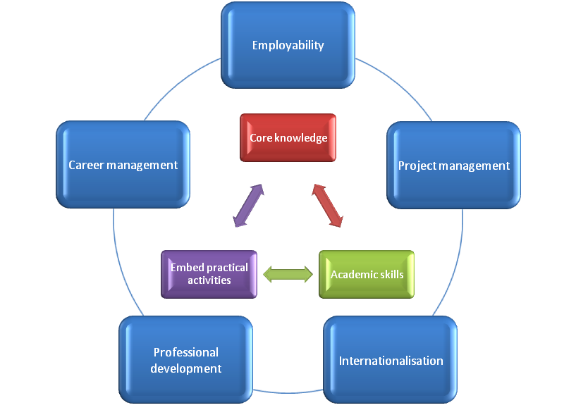

3.2 The approach to Assessment and Feedback within the Programme

A key feature of any Psychology based programme is the focus placed upon students developing an understanding of the discipline by carrying out a significant amount of laboratory and fieldwork based learning and assessment, covering a wide range of methodologies and involving quantitative and qualitative data analysis (QAA, 2007, Psychology Subject Benchmarks).

Within the course a number of different forms of assessment are planned, which are explicitly designed to assess a number of key subject benchmarks:

Laboratory reports to assess students’ ability to generate research questions and hypotheses, to select and use research methodologies and data analytical techniques appropriately;
Research methods workbooks to demonstrate systematic knowledge of a range of research paradigms and analytical techniques;
Coursework essays to assess students’ abilities to draw on evidence in assessing the relative merits of competing explanations of human behaviour, social situations and events in order to make critical judgements and draw reasoned conclusions;
The completion of ethics proformas to assess students’ awareness of ethical principles and their ability to apply these principles to their study;
An empirical research project, for students to demonstrate that they can design, conduct and report on an empirically based research project under the supervision of a psychology tutor;
Poster presentations to assess students’ abilities to communicate their ideas by written, oral and visual means;
E-portfolios to assess students’ abilities to take charge of their own learning, by reflecting on, and providing evidence of, their progress by evaluating personal strengths and weaknesses; setting out plans of action to improve their learning skills; and in the application of psychology and sociology to the work place.

The course has therefore been carefully designed to ensure that the assessment is fit for purpose and allows the students to demonstrate that they have met the learning outcomes for each module. The course team have also sought to ensure that there is a balanced assessment diet within and across each level of study and a supported progression between levels of study, in order to ensure that the course has an overall integrity. This is monitored on an annual basis in advance of teaching at course and programme assessment moderation meetings.

Feedback is central to our assessment design and draws upon the principles set out in the 2010 Faculty Feedback Policy. Formative feedback is an essential part of learning and in response to this recent policy guidance; our policy is to provide formative feedback within six weeks of the start of teaching in all modules. This enables students to get early feedback on all of their modules to orient themselves to the module and begin to work on their assessments in earnest. We also recognise the particular needs of students during their transition to higher education; in terms of becoming familiar with the specialist language of their disciplines and the differing demands placed on them in higher education. For the BSc Psychology and Sociology students, there is a recognition that these students will need to become familiar with the language of both disciplines and they will be supported and guided in situations where the academic conventions differ (such as referencing, for example). The level 4 module, Academic Development and Personal Tuition (ADAPT), provides the intensive level of support needed for new students as they make this transition. Within this module, BSc Psychology and Sociology students will have their own tutorial groups, so that the material and guidance will be tailored to be cohort specific with input from Sociology as well as Psychology staff. Following assessment during semester 1 of their first year, PASS tutors work individually with their tutees to understand and reflect on the feedback they have received in each of their modules. This one-to-one support of students continues throughout the course through the additional academic support time built into the Academic and Professional Development modules at levels 5 and 6.

Whilst recognising the key importance of formative feedback, we also understand the importance of providing summative feedback following assessment. Our approach to such feedback is to ensure that this feedback is supportive and geared towards consolidation and improvement, by identifying approaches that students can take with them into subsequent assessments or other modules.

4 PROGRAMME DESIGN AND STRUCTURE

The BSc Psychology and Sociology course has been designed with reference to a number of important stakeholders including staff, students and an external organisation, the British Psychological Society.

The course has three design principles:

A progressive design to developing discipline knowledge, enabling students to gain solid foundational knowledge in the core areas of psychology and sociology across the first two levels of the degree, with opportunities for more specialised, in-depth, critical and self-directed study at level 6;
To foster connections between methodological and theoretical knowledge by embedding the practical and research elements of the course within a wide range of topics from across the core areas of psychology and sociology;
A robust system of skills development (personal and transferable skills) and individual academic support for students in the transition to, progress through and exit from the course into employment and/or further study.

Figure 5. Course Design Principles for BSc Psychology & Sociology

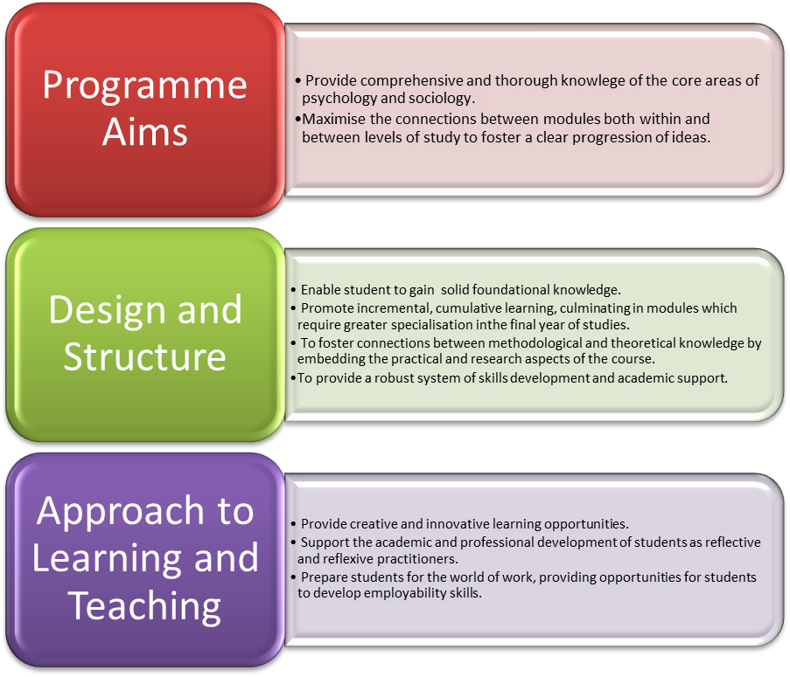

This joint honours degree is designed to maximise the connections between modules both within and between levels of study to enable students to make connections between modules and to recognise a clear progression of ideas through the three levels of the degree. Theory and research modules form the academic spine of the degree, incorporating as it does the core areas of psychology and the key themes of social identity, social inequality and social change within sociology. Academic and professional development are integrated within the course at all levels of study, progressing from a focus on academic and skills development in level 4, to a focus on professional development and employability in the final year of studies.

Level 4 provides students with a solid grounding in the sociological perspective and the core areas of psychology at an introductory level. Modules at level 4 therefore focus on key theoretical and methodological approaches. We recognise the importance of supporting students in the transition to higher education and the challenges that this transition poses for students. Our L4 modules are underpinned by an academic skills and support module (Academic Development and Personal Tuition – ADAPT). This module, under a number of different titles over the years, has been at the heart of our first year experience. This module draws on discipline specific content from Psychology to help students to develop the skills that they need for undergraduate study and personal/professional development. It supports students in developing the skills to locate, retrieve and evaluate information and to identify and analyse academic arguments. In addition to supporting students in developing such skills, the PASS module also introduces students to university life and the related practices and procedures of such an institution. It provides an extended induction programme as the tutors teaching on this module also become the students’ personal tutor and meet with the students in a tutorial group of about 6-8 students whom they continue to support throughout the three years of the degree. This extended induction programme also provides the opportunity for groupwork and individual tutorials which continue throughout the degree to support the academic and professional development of students.

Level 4: All modules are mandatory
Semester 1 | Semester 2
Fundamentals of Psychology 1
Mandatory (20 credits)
Fundamentals of Psychology 2
Mandatory (20 credits)
Academic Development and Personal Tuition
Mandatory (20 credits)
The Sociological Imagination
Mandatory (20 credits)
Shaping Societies
Mandatory (20 credits)
Researching Society
Mandatory (20 credits)

Personal and academic planning and professional development are therefore integrated from the outset on the BSc Psychology & Sociology course. This is continued at levels 5 and 6 by mandatory modules in Academic and Professional Development, taught by the same tutors and delivered in the same tutorial group format. The aim of these modules is to support students academically, whilst at the same time helping them to develop competence and confidence in career planning and decision making, to recognise, develop and document their skills and to leave the course well-equipped for further study or employment. Students’ academic and professional development is supported by the provision of an electronic portfolio, which students use throughout their time on the course and can, if they choose, continue to use after they have graduated.

The core areas studied in level 4 are built upon in level 5 of the course, in order to ensure the development of students’ knowledge of the theoretical and methodological core areas of psychology and sociology.

Level 5: All modules are mandatory
Semester 1 | Semester 2
Cognition  Mandatory (10 credits) | Biopsychology  Mandatory (10 credits)
Developmental Psychology  Mandatory (10 credits) | Personality and Intelligence  Mandatory (10 credits)
Changing Societies  Mandatory (10 credits) | Modernity and its Futures  Mandatory (10 credits)
Diversity and Equality  Mandatory (10 credits) | Identity and Representation  Mandatory (10 credits)
Quantitative Methods and Statistics  Mandatory (20 credits) | Qualitative Sociological Research  Mandatory (10 credits)
Academic and Professional Development
Mandatory (10 credits)

As a joint honours course and one which seeks to receive accreditation by the British Psychological Society, there are certain core areas within psychology and benchmark areas in sociology which each need to receive significant coverage. The result is that all of the modules in level 5 of this joint award are mandatory modules. However, the modules have been designed to be semester-long in order to open up the possibility for study abroad in semester 2. If the partner institution is able to offer modules which match these semester 2 mandatory modules, to ensure consistency of content in order to meet the Programme aims and learning outcomes, then the BSc Psychology and Sociology students will be given the opportunity to apply for study abroad in Semester 2 of Level 5. We believe that the experience of studying abroad can broaden students’ horizons for future study and employment. Therefore if a suitable structure is offered by a partner institution, then these students will be offered the opportunity to study abroad. Applicants are interviewed to check their suitability, with students accepted ‘subject to satisfactory performance in their Level 4 modules’. Sheffield Hallam currently has exchange agreements with universities in the Netherlands, Finland, Estonia, the US and Canada and is progressing agreements with other European universities.

In the final year of study, students have one further core psychology module to study (Social Psychology and Qualitative Research Methods) and also have the opportunity to study more specialised modules, reflecting the areas of expertise within the department. This provides students with the opportunity to tailor their course, to a certain level, in line with their interests and their career or future study aspirations. In the final year students will take more responsibility for their own learning, applying a more critical stance to their studies, culminating in particular in the completion of an empirically based project. In accordance with the stipulations of the British Psychological Society, students’ final year Psychology Research project will be supervised, taught and examined by psychologists. Undertaking a final year research project of this nature enables students to apply their psychology knowledge and skills to investigate an area of particular interest to them.

The employability of our students is a key concern. In addition to the Academic and Professional Development modules, BSc Psychology and Sociology students are also required to engage in work-related learning in their final year of study. For this work-related learning, students have the opportunity to experience the challenges of implementing psychology and sociology knowledge and skills in real world contexts, as part of the ‘Project Management’ module. In this work-related module, students therefore make explicit links between theoretical perspectives from within psychology and sociology and reflect upon their transferable skills. As part of this module, students will gain experience of working as part of a project team and taking responsibility for identifying goals, taking action and providing solutions. Students will be working in a real world context by working alongside an academic member of staff, or with an external client, or a student group, on a research or work-based project.

Level 6:
Semester 1 | Semester 2
Psychology Research Project
Mandatory (30 credits)
Social Psychology and Qualitative Research Methods
Mandatory (20 credits)
Project Management
Mandatory (20 credits)
Elective Module (Psychology or Sociology)
(20 credits)
Elective Module (Sociology)
(20 credits)
Academic and Professional Development
Mandatory (10 credits)

Psychology Level 6 Elective Modules:
Addictive Behaviours (20 credits)
Atypical Child Development (20 credits)
Clinical Psychology (20 credits)
Counselling and Psychotherapy (Theoretical perspectives) (20 credits)
Death, Dying and Bereavement (20 credits)
Evolutionary Psychology (20 credits)
Forensic Psychology (20 credits)
Health Psychology (20 credits)
Individual Differences and Mental Health (20 credits)
Language Acquisition and Development (20 credits)
Language and Speech (20 credits)
Neuropsychology (20 credits)
Organisations, Work and Psychology (20 credits)
Sexuality in Context (20 credits)
Social and Psychological Perspectives on the Environment (20 credits)
Sports and Exercise Psychology (20 credits)
Understanding Eating Behaviours (20 credits)
Weapons of Influence (20 credits)

Sociology Level 6 Elective Modules:
Advanced Research Methods (20 credits)
Belief, Meaning and Culture (20 credits)
Crime and the Media (20 credits)
Culture, Media and Consumption (20 credits)
Drug Use in Context (20 credits)
Education, Power and Control (20 credits)
Families and Kinship: A Global Perspective (20 credits)
Global Identities (20 credits)
Experiences of Health, Illness and Disability (20 credits)
Power, Sex and the Body (20 credits)
Work, Employment and Globalisation (20 credits)

Throughout the three levels of study, a guiding principle is to equip our students with a solid foundation for further study and employment through the provision of an innovative, applied and contemporary course, with scheduled and credit-bearing academic and professional development activities and dedicated academic and professional development tutors who guide not only the academic learning of their students, but also their career development.

5 PROGRESSION/CAREER ROUTES
Possible progression or career routes after you have completed this programme include

There are a number of possible career routes available to BSc Psychology & Sociology students on graduation. Social Science graduates proceed into a variety of careers in both the public and private sectors, due to the development of a wide range of transferable skills in written and oral communication, data manipulation, teamwork and critical thinking. They can also proceed to postgraduate degrees, either at Sheffield Hallam or elsewhere, and go on to undertake a PhD and follow a research or academic career. We offer a number of postgraduate awards at Sheffield Hallam and a number of our graduates from the department have progressed onto these awards, including the MSc Health Psychology, MSc Developmental Psychology and MSc Sports and Exercise Psychology. Our graduates have also progressed to undertake doctoral research within the department.

In examining the career routes for Psychology graduates, a third of such graduates go into the public sector, in health or social work, the civil service and education (QAA, 2007, Psychology Subject Benchmark Statement). The DLHE Survey (2010) reveals that a further third go into industry or commerce, such as market research, retail, property development or personnel management. Around a fifth of graduates go on to work as a professional psychologist and the remainder teach or research in schools, colleges and universities.

The careers routes that are specifically for professional psychologists all require further training. These major career routes are Clinical Psychology, Educational Psychology, Occupational Psychology, Health Psychology, Forensic Psychology and Counselling Psychology. Given the interest that many of our graduates have in careers in these areas, we ensure that the Psychology degree route and this joint degree with Sociology engage with key issues and debates in these more specialised areas of knowledge and employment. We will be seeking accreditation from the British Psychological Society for the BSc Psychology and Sociology course, to confer eligibility for the Graduate Basis for Chartered Membership, provided the minimum standard of a Lower Second Class Honours is achieved. Such completion of the course, subject to accreditation, would be the minimum requirement for entry to professional psychology training courses and therefore the first step to becoming a Chartered Psychologist.

6 ENTRY REQUIREMENTS AND ENTRY PROFILE

6.1 Specific Entry Requirements for entry to the initial stage of this programme are

Academic Qualifications including GCE A / AS level grades and subjects, where applicable | 260 points from at least two GCE/VCE A levels or BTEC National qualifications. We do not accept General Studies. AS qualifications may count towards these points. We do not consider Key Skills.  OR  Pre-2003 BTEC/SCOTVEC – National Certificate/Diploma in relevant subjects with distinctions in five modules in the final year.  OR  Access: at least 45 credits at level 3 from a relevant Open College Network accredited course.
Level of English language capability | GCSE English Language grade C or above.  For students whose first language is not English, IELTS 6.5 is required.
Any other specific, formally certified qualifications (eg. BTEC HNs) | GCSE Mathematics grade C or above.
Previous relevant work or work-related experience | N/A
Any specific articulation arrangements recognised for this programme | N/A
Professional qualifications | N/A
Any other specific entry requirements | N/A

6.2 APPLICANT ENTRY PROFILE: the knowledge, skills and qualities etc. required to enable you to benefit from, and succeed on the programme of study are

Students will benefit from this course if they have an interest in the following:

Pursuing academic study in psychology and sociology and an ability to see the world from a variety of perspectives.
A desire to follow a career in a psychology related discipline, such as clinical, educational, health, occupational or forensic psychology or a related area such as teaching, human resources, social work or speech therapy.
Developing personal and academic skills in preparation for employment or further study.
Competence in writing and numeracy skills.

6.3 The University will select non-standard entrants to the programme in the following ways

We welcome applications from applicants with alternative qualifications or a combination of qualifications and work experience. Applications are welcomed from people of any age. This must show that the applicant would benefit from, and has the potential to, complete the course successfully.

6.4 Use of Prior Credit (APCL/APEL): prior certificated credit or prior experiential credit may be used within the Programme in the following ways

With prior certificated learning, applicants may gain exemption from certain features of the course, subject to standard University approval procedures. For example, students wishing to transfer from another degree course, at Sheffield Hallam University, or elsewhere, may gain exemption from specific Level 4 modules, or may apply for direct entry to Level 5 of the course. In both cases, equivalence would need to be established between the learning outcomes previously achieved and those of the modules or levels for which exemptions were sought.

