How to Plan the Perfect Career: Workbook
Activity 1: What are your Top Skills?
This activity will help you identify your top skills.
Move a smiley by each one you enjoy, find fun or makes you smile.
Move a thumbs up by the ones you are good at, for example you might have been told this by a friend or given a good mark in a subject using this.
Choose 3 - 6 which you have given a smiley and a thumbs up as your top skills.

Coming up with ideas

Leading others

Using a computer

Working with numbers
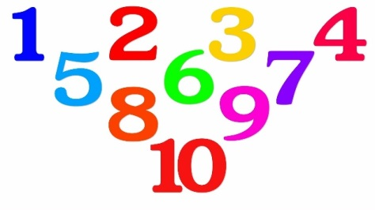

Managing money

Designing and drawing

Creating media

Performing music or drama

Writing or translating

Remembering
information

Communicating with others

Helping others

Team working

Asking questions

Solving problems

Using machinery and technology

Making or fixing things

Planning and Organising

My top skills are:

Sport and exercise

Selling things

Activity 2: What will you be looking for in a job?
The career area you choose will affect your lifestyle, the money you have and even the people meet. Look at each of the factors below and give each a score out of 10, thinking about how you would feel if your job included this.
1 = I definitely don’t want this 10 = I would definitely want this

Score out of 10

Earning lots of money
Being happy in my job
Doing similar things every day
Doing different things every day
Working set hours (eg. 9-5)
Working different hours such as evenings and weekends
Running my own business
Working in a close team
Working independently
Leading and managing others
Making a difference to others with my job
Working and living abroad
Getting chance to travel around the world
Working in the same place each day
Chance to progress and challenge myself
Having close friends at work
Working outside
Working inside
Being physically active in my work
Company benefits (e.g. gym or company car)
Working for a company with good ethics
Which are your top factors you would like in a job? (list your highest 5 scores)

