


ICT in the Early Years Conference
19 May 2005
Control Technology Workshop
Jayne Dinley
Sara Pass
Debbie Nunns
Tricia Nicholson

PIXIE
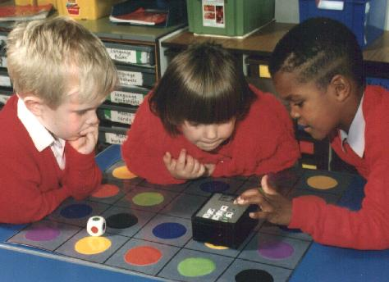

PIXIE is a simple robot. It is less than 6 inches across and has only 7 buttons. It is intended for use with children from 5 to 8 years but can be used appropriately for younger and older children.

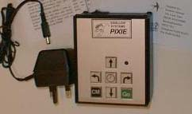
 programs PIXIE to move forward its own length.
 programs PIXIE to move backward its own length.
 programs PIXIE to turn a right angle to the left.
 programs PIXIE to turn a right angle to the right.
 programs PIXIE to wait for one second.
 (clear memory); rubs out the program in PIXIE.
 Makes PIXIE run the program.

PIXIE uses a counting paradigm for entering programs. If you want to use several units of movement or pause you just press the button the relevant number of times.
PIXIE has only two internal states. It is either waiting for a keypress to add to its program or it is executing the program.
The clear memory button needs to be pressed before starting to enter new instructions, even when PIXIE has just been turned on.
starts a program. Once running a program all the keys are "panic" buttons that will stop PIXIE if they are pressed.
It is impossible to generate a "syntax error". This simplicity makes PIXIE accessible to younger or less able children.

