Generic Software Workshop

Carys Bishopp
Joanne Dickson

Textease Toolbar
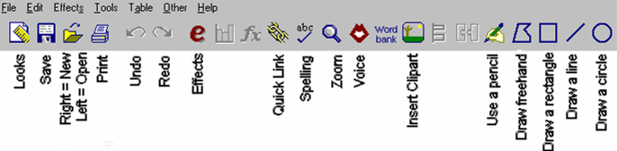

Dazzle toolbar

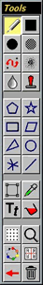
Teaching ideas for Textease

- Literacy - Write a story and have it read back to them with voice function using illustrations.
- Numeracy – Teacher can type sums into document and children can use voice function to read the sums to them. Children can also create graphs from data collected in another subject e.g. Science
- Science and Knowledge and Understanding of the World – Transfer data from experiment of how materials stretch, squeeze, twist etc and record data in a spreadsheet which is more child friendly than Excel
- Geography - Download pictures from the icon box such as mountains and animals. Ask the children to click and drag the pictures to sort them into categories- living things and physical things.

Teaching ideas for Dazzle
- Literacy – Illustrate a piece of writing or story.
- Numeracy – Shape and space – symmetrical patterns.
- Geography – Painting the route of a story after reading a story about a journey.

- History – Drawing a picture of George and the Dragon.
- Music – Graphical scores from instrument playing.
- Art – Create work inspired by other artists e.g. a William Morris style picture using stamp tool.

